**Environmental Policy Statement**

Detectronic Limited is committed to leading the industry sector by minimising the impact of its activities on the environment. Preventing pollution is our core business and this must include our own operations.

Key to our operational strategy:



* We shall maintain an Environmental Management System which addresses the requirements of ISO 14001: 2015 and is regularly verified by an accredited auditing organisation.

The Scope of Detectronic’s Environmental Management System covers:

* + Design, manufacture, sales, hire, marketing, maintenance of electronic monitoring and data logging equipment for the waste water industry, including for use in potentially explosive atmospheres, and the analysis of the resulting data.
* Ensure that increased workforce and business growth does not disproportionately increase our environmental impact.
* Develop objectives specific to minimisation of our current and potential environmental impacts and monitor performance against these objectives.
  + Improve Carbon Footprint
  + Ensure continuation of ‘0’ environmental spills/incidents
  + Establish a benchmark MPG for the fleet with a view to future reductions
* Minimise waste and energy consumption by evaluating operations and ensuring they are as efficient as possible.
* Minimise carbon emissions through the sensible selection and use of our vehicle fleet with advance route-planning and encourage the use of electronic communication reducing the need to travel.
* Actively promote recycling both internally and amongst customers and suppliers.
* Ensure operations prevent pollution and ensure that all environmental, legislative, regulatory and environmental codes of practice are identified and standards met or exceeded.
* Consider the reduction of our potential environmental impact at all stages of the design and improvement of our product range.
* Promote environmental awareness through training, educating and communicating requirements to all employees and on-site contractors so that they can carry out their activities in an environmentally responsible manner.
* Regularly review all aspects of our Environmental Management System.

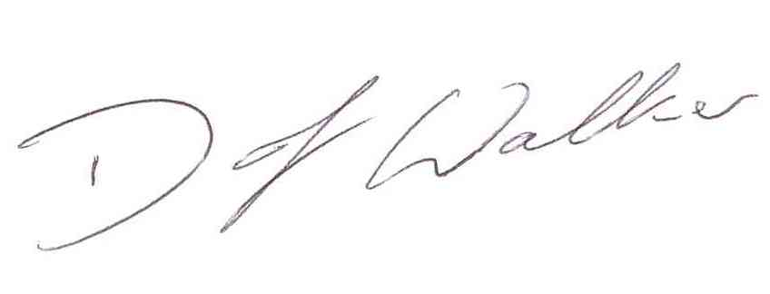Signed Signed

Steve Woods

David Walker BSc (Hon) Environmental Management

Managing Director Environmental Management Advisor